APPETIZERS
By the Dozen:
Mini Crab Cakes $14
Crab Stuffed Shrimp $16
Sausage/Crab Stuffed Mushrooms $14
Beef Sate $13
Prosciutto Wrapped Marinated Asparagus $12
Bruschetta w/Ricotta $12
Prosciutto Wrapped Chicken & Artichokes $13
Mini Soup Shooters $11
Mini Sandwiches $11
(Grilled cheese/Reuben/PB&J)
Wild Mushroom Phyllo $13
Tortilla Rollups $13
Bacon Wrapped Scallops $15
Skewered Grilled Marinated Shrimp $15
Anti Pasta Kabobs $12

By the Tray (Approx 30 ppl)
Fresh Fruit Tray (In Season) $65
Fresh Vegetable Tray $55
Taco Dip $50
Spinach Artichoke Dip $60
Cheese & Sausage Tray $55

BUFFETS

(For Groups of 25ppl or More)
Buffets include: Fresh Baked Rolls and Choice of Three Sides.

One Entrée $21
Two Entrée $23

Entrée Meats
Artichoke Chicken, Shrimp Adouille Pasta, Hawaiian Pork Tenderloin, Chicken Bruschetta, Dijon Chicken, Jamaican Jerk Chicken, Firecracker Salmon
Add $2.00 Per Person
Rosemary and Garlic Marinated Lamb Chops, Parmesan Encrusted Flounder, Chicken Marsala, 6oz Grilled Filet, Filet Medallions with Mushroom Sauce

Scrumptious Sides
Garlic Mashed Potatoes, Rice Pilaf, Roasted Potatoes, Sautéed Sweet Potatoes, Buttered Corn, Sautéed Green Beans, Vegetable Medley, Pasta Marinara, Pasta Alfredo, Tossed Salad, Caesar Salad, Potato Salad, Marinated Vegetable Salad, Marinated Italian Salad, and Pasta Salad

PLATED DINNERS

Beef:
Filet Mignon 6oz $23
Beef Wellington $28
Coffee Glazed New York Strip $22
Prime Rib - Queen or King Cut $15-$21
Poultry:
Cilantro Lime Chicken $15
Stuffed Chicken Breast $16
Soy Ginger Marinated Chicken Breasts $15
Proscuitto Wrapped Chicken Breasts $16
Seafood:
Cream Cheese and Crab Stuffed Prawns $21
Stuffed Flounder $17
Broiled Maine Lobster Tails $MP
Grilled Red Snapper with Lemon $17
Pork:
Citrus Marinated Grilled Pork Chop $16
Pork Medallions with Cherry Sauce $15
Vegetarian:
Couscous with Portabellas $12
Sundried Tomato and Asparagus Risotto $12
Combo Plates:
Filet and Lobster $MP
Coconut Shrimp and New York Strip $24

Desserts
Trays Serve Approx 30 ppl

Homemade Cookies $36
Chocolate Covered Strawberries $60
Mini Cheesecakes $55
Mini Eclairs $45
Cream Puffs $45
Assorted Dessert Tray $55

Twisted Cuisine is Willing to Customize a
Menu to Suite your Individual Tastes

All Parties are Subject to a 15% Service Charge

*** $50 Delivery Fee

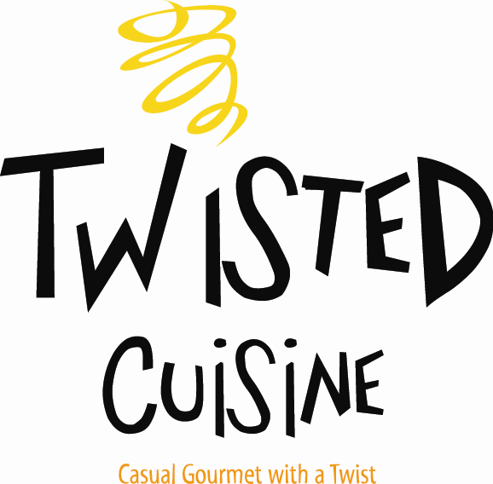

Catering Menu

Owners
Rhonda Eidsor
&
Heidi Naef

Executive Chef
Erica Buskirk

7546 Sheridan Road
Kenosha, WI 53143
(262) 564-0220
www.twistedcuisine.com

